LOCATION OR AREA(S) | CRIME(S) | Gang INFO | TASKS 114 &115
114  - Pacific Ave Corridor  - 18th & Pacific  - 18th St. corridor east/west  - Central Ave Corridor  *****PRIMARY AREA******* | - Burglaries  - Gang activity -throughout  - Stolen vehicle activity  - Drive by Shootings  - Shots fired | - Antonio Serrano  ‘DOWNER’  H/M 09/25/1996  1628 Woodland Blvd KCKS—DIME Block | - Increased visibility on Central  and crime map areas in the zone.  - All shifts Document suspicious persons /Gang on FIF’s  - Fingerprinting/Canvassing after J5’s  - Gang Activity/Drive By Shootings Follow ups
114  - Central Ave Corridor | - Robberies  - Narcotic Activity | - Anthony Bejarano  ‘CHAPO’  H/M 03/05/2003  207 S 25th St KCKS/2501 N 7th ST—TVS/SPV | - CFS taken from these areas if no extra manpower  - Increased positive citizen contacts all shifts. (FIFs, Ped checks, warning tickets)  - Gang Graffiti
115  - 7th street Corridor  - Central Ave Corridor  - 7th & Central Area  - 10th & Central area  *****PRIMARY AREA****** | - Burglaries-Shift I  - Gang activity  - Stolen vehicle activity  - Drive by Shootings  - Shots fired | - Raul Ortega-Carrillo  ‘COOKIE’  H/M 10/28/1997  1114 Pacific Ave KCKS---TVS/SPV | - Business checks (nighttime and weekend)  - Increase visibility and late night, early morning, weekend presence
115  - 9th & Reynolds | - Tires dumping  - Drive by Shootings  - Shots fired  - Vans/Trucks J5 to auto  - Narcotic Activity | - Aron Palomares  H/M 02/11/1995  258 N Mill KCKS—DIME BLOCK/F13  *CFS taken from the areas. *Suspect follow-up (increased FIF on gang)  *Code issues and nuisance vehicles addressed and or documented on observation memos. *Increased canvassing and printing efforts.  *Increased presence during pattern times. *Increase traffic enforcement (radar, tint, school zones, etc.). | - Shootings follow-up  - Traffic enforcement (use their lights and be visible)  - Probation subjects
EPD DDACTS Patrol Quick Reference June 1st 2017
*Consult COMSTAT report maps and incident chart for times and other patterns.

Residential Burglaries last quarter Burglary to Autos last quarter
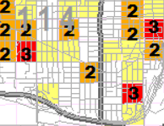
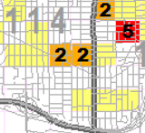

Violent Crime incidents and Violent Crime EPS Last Quarter
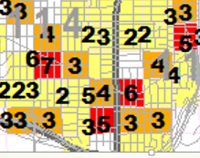

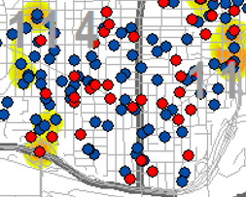
EPS Target Crimes last 30 days
Red is past week blue is last four weeks.

Drive by Shootings, Shootings, Homicides and Aggravated Assaults in the DDACTS Zone Since Jan 1st
Case # | Address and Date | Victim Info | Suspect info
2016001212 | 623 S 11TH ST 1/4/2017 | GUTIERREZ, ELENA | Unknown
2016-002848 | 324 N COY ST 1/9/17 | DAMIAN, LUCERO/1 OTHER VIC | Unknown
2017-004634 | N VALLEY & RIDGE 1-18-17 | FRANCO, ROGELIO/2 OTHER VICS | Unknown
2017-014970 | 12 N MILL ST 2-13-17 | CONTERAS, ELIZABETH | HM, GOLD SUV BLUE HEADLIGHTS
2017-16680 | 900 BLK OF IVANDALE 2/18/17 | LEHMKUHL, PATRICIA | WM RED SPORTS CAR
2017-28032 | 6TH ST AND SANDUSKY 3/22/17 | MEYORGA, PARRA-ARREOLA, RAMIREZ | DARK CHARGER, .22 CASINGS
2017-28374 | 241 S 18TH ST 3/22/17 | TAGLE-OLIVARES, EUNICE | BM , GREEN HONDA FIT KS TAG, HANDGUN
2017-028773 | 1222 CENTRAL 3/23/17 | GALACEZ-ALMAZO, CESAR | GRAY PONTIAC, HM, HANDGUN
2017-29013 | 249 N 16TH ST 03/23/2017 | MORENO, JUAN | UNKNOWN
2017-029541 | CENTRAL AND PYLE 03/25/2017 | ESCOBAR/GONZALEZ/VALLADARES | CASTELLANO-DUBON, EDWIN HM 05/07/1989, RED HONDA CIVIC
2017-32696 | 345 S BETHANY 4/3/2017 | GUTIERREZ, LEYLA | 02 GRN OR BRN TAHOE 2 HM, 08 BLK GMC DENALI 2HM, GRN OR BRN NISSAN ALTIMA 2 HM
2017-39190 | 1240 CENTRAL 4/20/2017 | BM | UNKNOWN
2017-41669 | 18TH ST AND PACIFIC 4/26/2017 | UNK | BM / WF WHITE GMC YUKON 263KGF,KS
2017-43137 | MILL AND CENTRAL 5/1/2017 | EVANS, ALFONSO | WHITE CHEVY SILVERADO, HM
2017-43915 | 709 S COY 5/2/2017 | NIMMO, PAMELA / SANABRIA, TONY | UNKNOWN
2017-44069 | 16TH ST AND BUNKER 5/3/2017 | JONES, MARQUIS / ROSS, MIKAYL | BLUE SUV, SILVER TOYOTA CAMRY 781HVL
2017-44242 | 1007 GILMORE 5/3/2017 | OLIVAS, SECUNDINO/VILLEGAS, MARIA | BLACK FORD CROWN VIC
2017-44272 | 258 N MILL ST 5/3/2017 | PALOMARES, AARON | WHITE CHEVY IMPALA
2017-44538 | 954 GILMORE 5/4/2017 | HERNANDEZ, CARLOS | BLACK CAR
2017-44488 | I70 AND 18TH ST 5/4/2017 | PIERSEE, RON | BLK CHEVY SUV
2017-45650 | 272 N 9TH ST 5/7/2017 | MADRIGAL, AMABOR / MADRIGAL, INGILVERTO | FRANCO, MARCOS WM 02/15/1985
2017-49248 | 1226 OHIO 5/17/2017 | GUERRO, MARIA | BLUE VEH 2 HM'S
2017-49673 | I 70 AND 18TH ST 5/18/2017 | OMANOVIC, MUNIR | RED/MAROON TRUCK POSSIBLE DODGE BM 20YO
2017-54590 | 250 N 18th St 5/30/2017 | Gurrola, Migue/Gurrola, Rodolfo  Portillo, Mirka | Unknown

Shots fired calls from January 1st Shots fired calls from May 1st to May 31st
to May 31st 2017

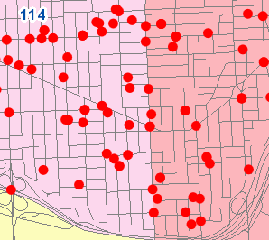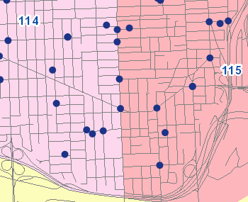

This map shows where all of the documented gang members are living within the zone. Actual Names and addresses will be forthcoming.
